Practical 10: Hash Tables: Linear Probing, Chaining, and Double Hashing
Practical Aim
To implement hash tables using different collision handling strategies and develop the ability to reason about why collisions occur, how different strategies resolve them, and what trade-offs each approach involves.
Problem 1
A small parking lot has exactly 10 numbered slots (0 to 9). When a vehicle arrives, its registration number is used to assign it a slot by taking the last digit of the number. If that slot is already taken, the vehicle moves to the next available slot in order, wrapping around if necessary. Given a sequence of vehicle registrations, assign each to a slot using this rule and display the final state of all ten slots.
Describe what your solution does when it encounters an already occupied slot. What happens when the parking lot is nearly full and many vehicles keep landing on the same slot? Can you think of a situation where your solution might loop indefinitely?
SOLUTION:
https://github.com/prathameshpandir-dev/DSA-Batch-B-SHP/tree/main/practical-10
OUTPUT:
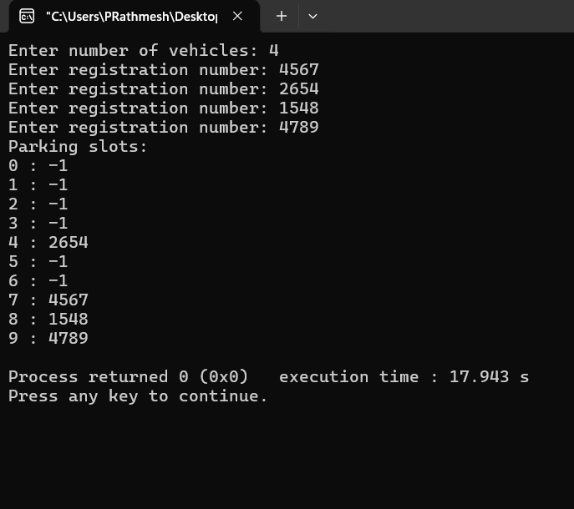

PROBLEM FACED:
The main difficulty was handling collisions and wrapping around the table. The program must also stop when all ten slots have been checked so that it does not search forever.
CONCLUSION:
The linear probing hash table was successfully implemented. When a slot is occupied, the next available slot is searched in order with wrap-around.
Problem 2
A library uses a system with 10 shelves numbered 0 to 9. Each book's code is used to decide which shelf it belongs to by taking the code modulo 10. Unlike the parking lot, each shelf can hold multiple books stacked together — when two books map to the same shelf, they are simply added to that shelf's stack. Given a sequence of book codes, place each on the correct shelf and display the final contents of all shelves.
Describe how your solution handles two books that map to the same shelf. What happens to search time on a shelf as more and more books pile onto it? Can you think of what would cause all books to end up on the same shelf?
SOLUTION:
https://github.com/prathameshpandir-dev/DSA-Batch-B-SHP/tree/main/practical-10
OUTPUT:
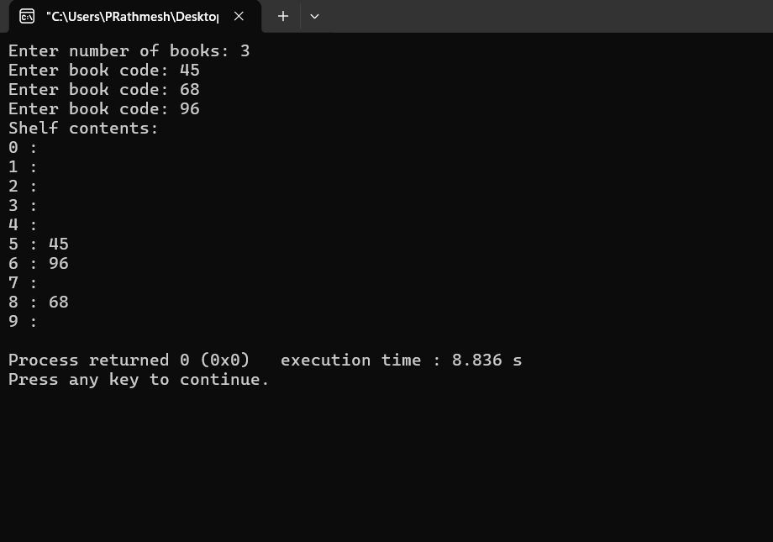

PROBLEM FACED:
The main difficulty was maintaining a separate chain for every shelf and adding new books without losing the existing books in the chain.
CONCLUSION:
Chaining was successfully implemented using linked lists. Multiple book codes can be stored at the same hash index without replacing earlier values.
Problem 3
A university assigns student IDs to storage slots using a two-step rule. The first rule determines the initial slot. If that slot is taken, instead of simply moving one slot forward, a second rule based on the ID itself determines how many slots to jump. This means different IDs that collide will probe different sequences of slots, spreading them more evenly. Given a sequence of student IDs, assign each to a slot using both rules and display the final state of the table.
Describe how your solution decides how many slots to jump when a collision occurs. What is the risk if the jump size happens to be a factor of the table size? How does this strategy differ from Problem 10.1 in how it spreads collisions?
SOLUTION:
https://github.com/prathameshpandir-dev/DSA-Batch-B-SHP/tree/main/practical-10
OUTPUT:
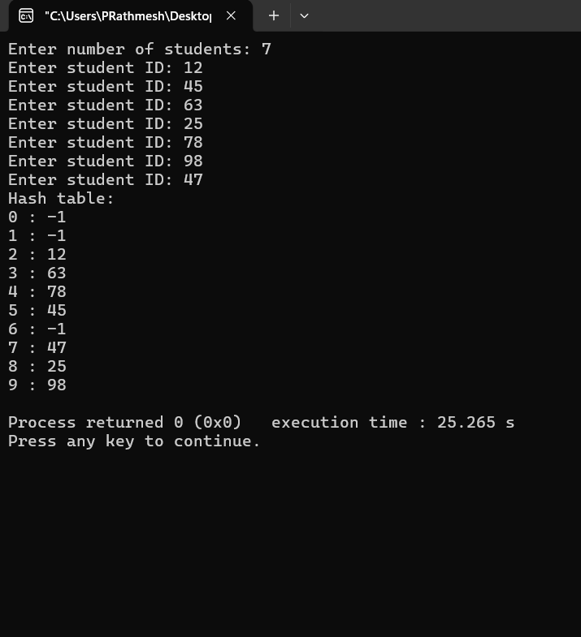

PROBLEM FACED:
The main difficulty was choosing a second hash function that gives a useful non-zero jump size and applying it correctly for every collision.
CONCLUSION:
Double hashing was successfully implemented using a second hash function for the jump size. This gives different probe sequences for different keys and reduces the clustering seen in linear probing.
Key questions
1. Problem 1
Answer: If five consecutive registrations have the same last digit, linear probing places them in consecutive slots. This creates primary clustering because groups of occupied slots grow together, making later searches longer.
2. Problem 2
Answer: If all book codes are multiples of 10, code modulo 10 is always 0, so every book is placed in shelf 0. This shows that a hash function must distribute the expected input values well.
3. Problem 3
Answer: If the second hash function always gives a jump of zero, a collision causes the program to keep checking the same slot. No other position is reached, so insertion can fail or loop indefinitely. This is a problem with the second hash function.
Overall Conclusion
The practical successfully implemented three collision handling methods: linear probing, chaining, and double hashing. The practical showed how different collision strategies affect clustering, storage, and probe sequences.

